**Multi-path Propagation**

**Simulation Laboratory Session**

**Wireless Communications 371-1-1903**

**Spring 2020**

# Option 1 - OMNeT++ with INET

In this part we will simulate how to measure reflections and shadowing.

You will write a program that reads the following parameters:

* Floor: length and width.
* Obstacles: Wall, Furnitures and more, by geometry parameters.
* AP: Place of the signal’s source.

In the program, the program should create a path, where the received signal’s power will be simulated along that path.

Using the results given of from the program, you will create a plot of the received signal at the points $P=f(x,y)$, that generates a topographic map of one line.

It is recommend to use the ratecontrol showcase that is given in the INET package of the OMNeT++

[inet/showcases/wireless/ratecontrol at master · inet-framework/inet](https://github.com/inet-framework/inet/tree/master/showcases/wireless/ratecontrol)

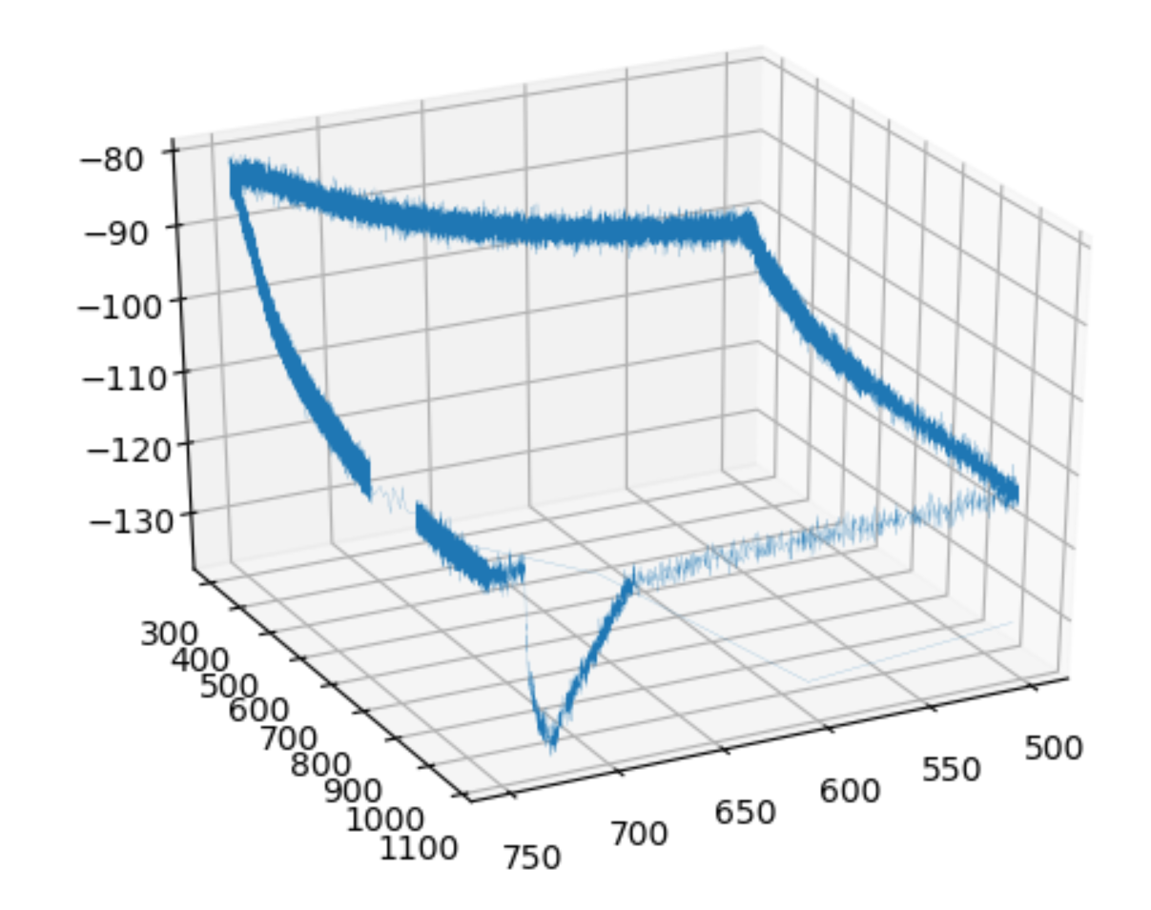

The requested result is given in the above figure, your first mission is to provide names and units to the above figure’s axis.

1. As seen, the above figure lacks a title, neither names for the axis.
   1. Provide a title to the figure, what does the figure describe?
   2. Provide names and units to the axises. Explain each axis’s name and unit properly.
2. Find or generate a building floor plan (including at least 4 walls and 2 obstacles) and draw a path on it. The path should be at least 100m in total.
3. Place your AP at a fixed point along the path.
4. Place a mobile host that will move along the same path while constantly sending and receiving messages from the AP.
5. All message traffic, power and location $(x,y,z)$ should be recorded in order to create the following graphs:
   1. Power along the path using RayleighFading, LogNormalShadowing propagation models.
   2. Throughput along the path using RayleighFading, LogNormalShadowing propagation models.
6. You should record a video with one minute (60 seconds) of your simulation, show on the video the ini file with the simulation parameters.

**All of your work should be presented and thoroughly explained (including code).**

Installing OMNeT++:

|  |
| --- |
| wget https://github.com/omnetpp/omnetpp/releases/download/omnetpp-5.6.1/omnetpp-5.6.1-src-linux.tgz tar -xf omnetpp-5.6.1-src-linux.tgz cd omnetpp-5.6.1 source setenv ./configure make  omnetpp |

Add INET as reference:

|  |
| --- |
| wget https://github.com/inet-framework/inet/releases/download/v4.2.0/inet-4.2.0-src.tgz tar -xf inet-4.2.0-src.tgz |

In your OMNeT++ workspace import INET as Project

References and Tools:

<https://inet.omnetpp.org/>

<https://doc.omnetpp.org/pandas-tutorial/>

[https://colab.research.google.com/](https://colab.research.google.com/d)

Materials add or change:

<https://github.com/inet-framework/inet/blob/master/src/inet/environment/common/MaterialRegistry.cc>

# Option 2 - MATLAB/GNU Octave/Mathematica/Else

# Write a program that generates a 3D Map the power of a received signal using:

1. The Simplified Path Loss Model propagation model found in chapter 2.5 in Wireless communications, Andrea Goldsmith, Stanford University, California, 2005, 9780511841224.
2. In addition to the LOS ray, take into account rays that are reflected only once.

The inputs are the dimensions of the room, the location of the transmitter (AP), the transmitter power and the frequency (wavelength).

The output is a 3D map (graph) describing the power received in every location in the room for each scenario (Power , X , Y , Z).

# Part 3

# Given the multipath models with two-ray as seen in class.

Write a program that get the following arguments:

1. Path Difference
2. Phase Difference
3. Amplitude Difference [dB]

Plot the amplitude difference of the two rays $\frac{A}{A_{1}}$, where $A$ is the sum of the two paths amplitudes, and $A_{1}$ is the amplitude of the LOS path.

Your plot should be at least 10MHz around the following frequencies:

1. 900 MHz
2. 2125 MHz
3. 2437 MHz
4. 5260 MHz
5. 433.92 MHz

Each pair will plot only one plot by $1 + Pair \# mod 5$, e.g. Pair 6, will have a plot with frequency number 2 (2125 MHz).

E.g. given the arguments $(150m,\frac{π}{3},2dB)$, and 855MHz:

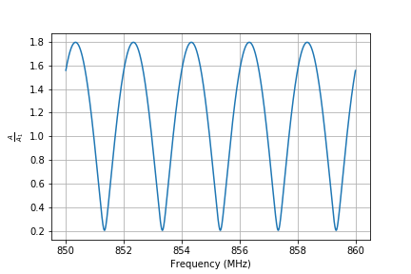

Repeat that, and now for $k$-rays, give a plot of your pair number of rays + 2, e.g. pair 6 will give a plot of 8-rays, up to 10, that is pairs 8-10 will plot 10-rays.